**Type the following URL in the browser**

<http://localhost:8888/>

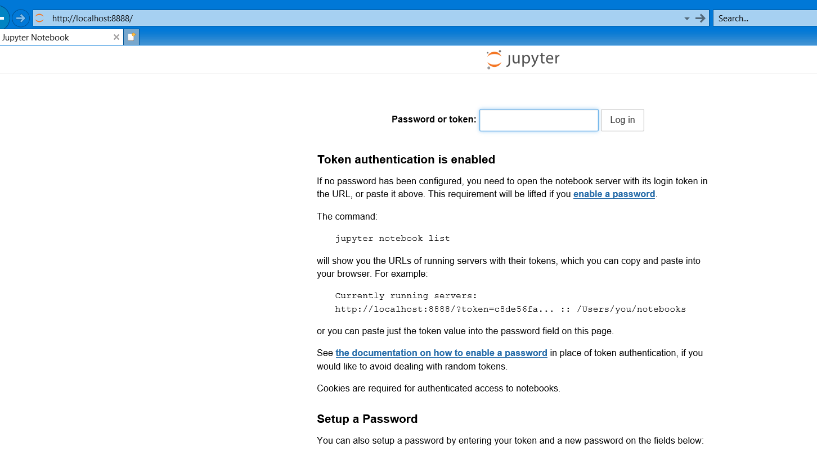

**Copy the highlighted token to a notepad**

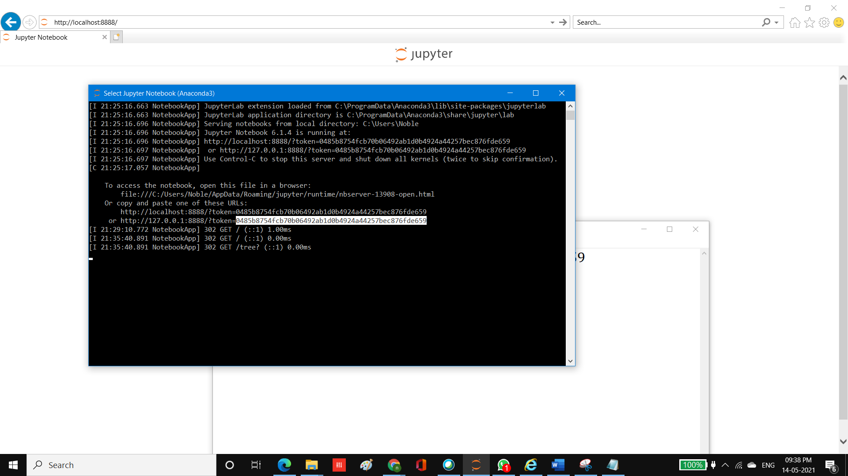

**Remove Leading and Trailing Spaces if exists**

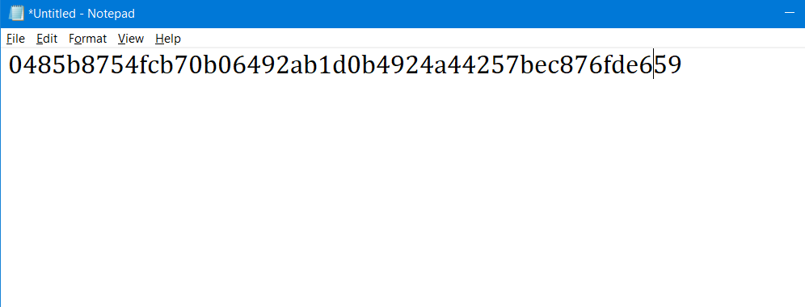

**Copy the token to the password or token Box and click log on Button**

